Equations: p = mv J = F*t = mv_{f} – mv_{i} m₁v_{1i} + m₂v_{2i} = m₁v_{1f} + m₂v_{2f}

- Explain the difference between an “elastic collision” and an “inelastic collision”. What is conserved in both collisions?

- Calculate the momentum of an electron (mass = $9.11×{10}^{-31}$ kg) moving at 1/3 the speed of light (light speed is $c=3.00×{10}^{8}$ m/s ).

- Sal has only 3/4 as much mass as Wilma, but she is running twice as fast. If Wilma's momentum is 500 kg$⋅$m/s, what is Sal's momentum?

- A toy truck of mass 25 kg moving at +6 m/s slams into a home and bounces back with a velocity of -2 m/s.
- What is the change in momentum of the truck?

- If the time of impact is 0.05 s, calculate the force of impact on the truck.

- If the stopping time from part B is increased to 0.20s, what would happen to the force? Circle the answer: Increase Decrease Stay the Same

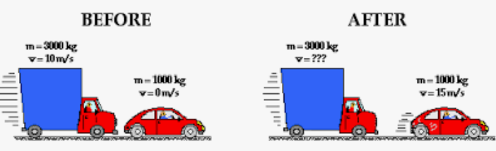
5) A 30 kg blue truck traveling with a velocity of +10 m/s hits a 10 kg red car that is initially at rest. After the collision, the red car’s velocity is +15m/s.
  - Calculate the blue truck’s velocity after the collision.

  - What is the initial kinetic Energy before collision?

  - What is the final kinetic energy after collision? Find Energy loss.

  - What type of collision occurs in the problem above? Justify your answer
Elastic Inelastic

